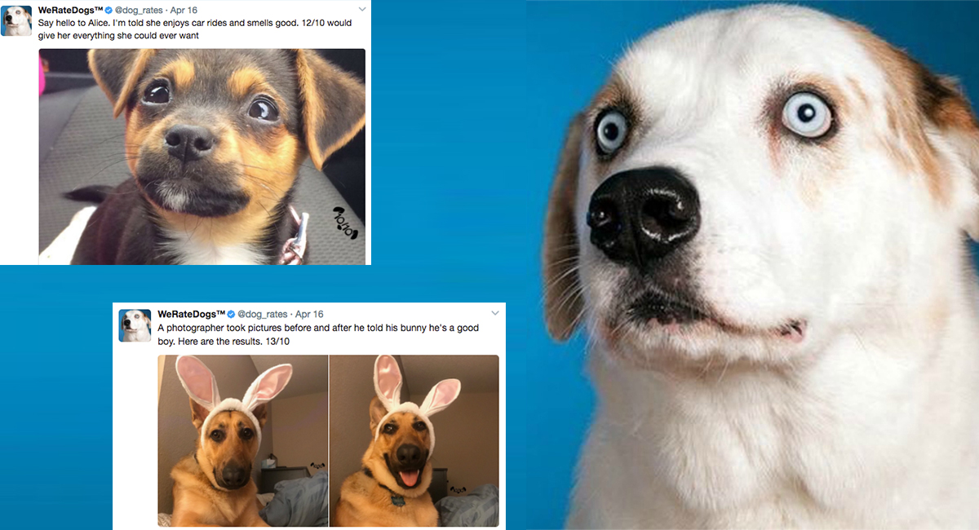**We rate Dogs Magazine**

The place where the cutie dogs live. In this small article we are going to show you some facts about those dogs in order to get in touch with honest creatures and learning more about what people like the most about them, so let’s get started.

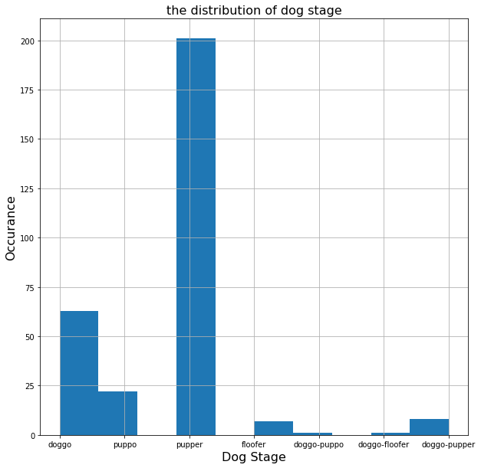**Insight 1 : the distribution of dog stage among the posts.**

As shown in the figure above we can see that the vast majority of people posts have [pupper] dog stage in their posts by about 200 times.

**Insight 2**: While the [pupper] dog stage has the highest appearance in posts as mentioned

but they have not earned the highest number of retweets and likes.

And the posts that have done this are the ones that contains [doggo-puppo].

* 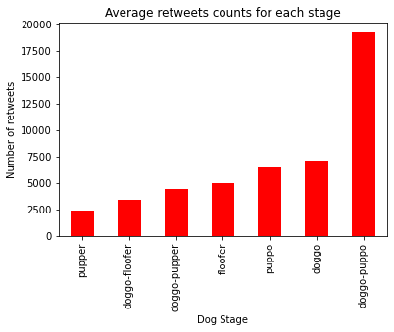**The average retweets rate for each dog stage.**
* 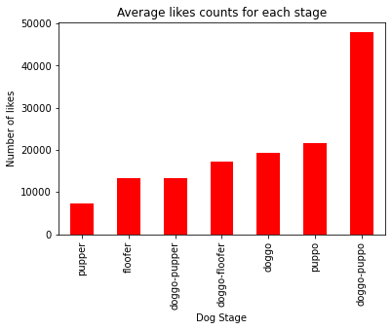**The average likes rate for each dog stage.**

## Insight 3 : Dog breeds that got the highest rate of confidence in the first

## phase of prediction. The figure below says that the breed of

## [golden_retriver].

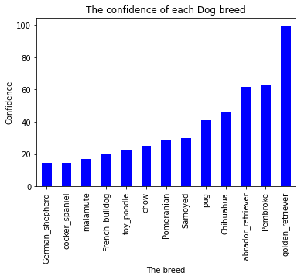

## Insight 4: The accuracy and confidence for each prediction level is acceptable, but the confidence varies.

* First level (high accuracy – high confidence)

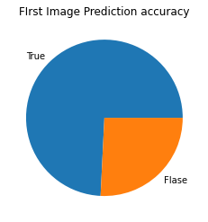

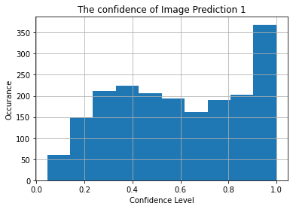

* Second level (high accuracy – low confidence)

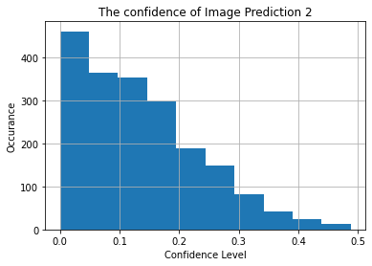

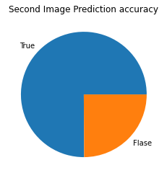

* Third level (high accuracy – low confidence)

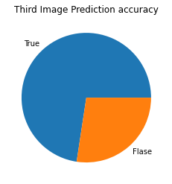

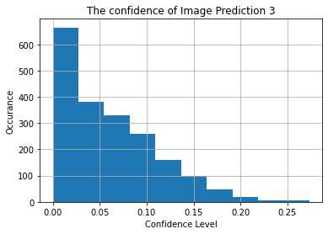

## Insight 5: The All ratings seemed satisfied with puppies’ photos, with a

## relative distribution as follows (1 means 100%)

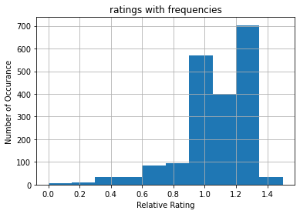

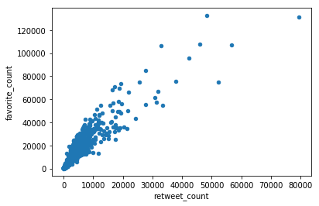**Insight 6:The number of retweets has a positive correlation between the number of likes. The answer of this is going to be way too clear by the figure below:**